Systems and Processes
System. In thermodynamics, a substance or group of substances in which we have special interest where exchange of energy is taking place is called a system.
Ex: A reaction vessel, a distillation column, or a heat engine.
Process. The changes taking place within the system is referred to as a process.
Ex: Hydrocarbon fuel and oxygen in a combustion chamber.
Surroundings. The part of the universe outside the system and separated from the system by boundaries is called surroundings. The boundaries may be either physical or imaginary; they may be rigid or movable.
Open system: A system where mass and energy is taking place between system and surrounding is known as open system.
Closed system: A system where only energy is exchanging between system and surrounding is known as closed system.
Isolated system: A system where neither energy or mass is not exchanging between system and surrounding is known as closed system.

State and properties
Certain specifications such as pressure, volume, and temperature are necessary to define the conditions of a given system. The condition defined by such specifications is called the state of the system.
The variables used to define the state are called the state functions or the properties of the system.

State and Path Functions
State functions. Properties of a substance describe its present state and do not give a record of its previous history.
Path functions. The values of heat and work accompanying a given change in state vary with the path from the initial to the final state.
Force
According to Newton’s second law of motion, the force acting on a body is directly proportional to the time rate of change of momentum.
F is the force, m is the mass of the body, a is the acceleration
F = ma
mass 1 kg is accelerated by 1 m/s2, the force acting on the body is 1 kg m/s2, which
is designated as 1 newton or (1 N).
Pressure is defined as the normal component of the force per unit area exerted by the fluid on a real or imaginary boundary.
The unit of pressure in the SI system is newton per square metre (N/m2), also called the pascal (Pa). A multiple of pascal, called the bar, is also used as a unit of pressure.
1 bar = 105 Pa = 105 N/m2
The pressure exerted by the atmosphere is called the atmospheric pressure and it varies with location and elevation on the earth’s surface. One standard atmospheric pressure abbreviated as atm is used in all system of units as an empirical unit of pressure. It is the average pressure exerted by the earth’s atmosphere at sea level.
Pressure is sometimes expressed in terms of the height of the column of mercury, which it will support at a temperature of 273 K in a standard gravitational field. At standard atmospheric pressure this height is 0.76 m (760 mm or 760 torr) with density of mercury taken as 13.5951 103 kg/m3.

Energy
Work. Energy is expended in the form of work when a force acts through a distance. Thus,
dW = P dV
Heat. It is that quantity which is transferred between bodies due to the difference in temperatures existing between them.
Heat is now recognised as a form of energy that cannot be stored as such within the system, it is expressed in joules. Two other units used for heat are the calorie and the BTU (the British thermal unit).
1 calorie = 4.1868 J; 1 BTU = 1055.04 J

Energy. It is a quantity that can be stored within the system and can be exchanged between the system and the surroundings. The exchange of energy occurs either as heat or as work.
Energy possessed by the system due to its position above some arbitrary reference plane is referred to as its potential energy (PE).
If mass m is at an elevation z above the ground, the potential energy of the mass is
PE = mgz
where g is the acceleration due to gravity.
The energy possessed by the body by virtue of its motion is called its kinetic energy (KE). If a body of mass m is moving at a velocity u, the kinetic energy of the body is As is obvious, the kinetic energy and potential energy are not thermodynamic properties of the system.
KE = ½ mv²
The unit of energy in SI system is joule (J).
Internal Energy: It is a energy created due to the rotational, vibration of molecules with in the system.
Power. It is defined as the time rate of doing work. Its unit in the SI system is J/s, commonly designated as W (watts). In engineering calculations, power is sometimes expressed as horsepower (hp).
Hence, 1 hp = 745.7 W.
Equilibrium State
A system is said to be in a state of equilibrium if the properties are uniform throughout and they do not vary with time.
A system is in thermal equilibrium, when no heat exchange occurs between various points within the system and the temperature is uniform throughout.
In a system which is in mechanical equilibrium, the pressure is uniform.
Chemical equilibrium: In a system the chemical composition are uniform with in the system.
Biological equilibrium: In a system if the metabolism is uniform with in the system.

Zeroth Law
Let a body A be brought in thermal contact with another body B. Heat flows from one to the other and eventually thermal equilibrium is established between A and B. If another body C is also in thermal equilibrium with B, then it is experimentally observed that A and C are also in thermal equilibrium.

HEAT RESERVOIRS AND HEAT ENGINES
Heat Source
A Heat source is a sufficiently large system in stable equilibrium from which finite amount of heat can be obsorbed from the system without any change in its temperature.

Heat sink
A Heat sink is a sufficiently large system in stable equilibrium from which finite amount of heat can be transferred from the system with out any change in its temperature.
A heat source is a high temperature
Heat Engine

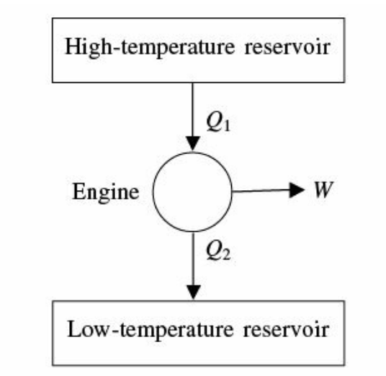
A heat engine is a thermodynamic system operating in a cycle to which heat is transferred from source, work is done to the sorroundings and remaining is transferred to sink.

Heat Pump
A heat pump is a thermodynamic system operating in a cycle that removes heat from a sink by doing work from sorroundings to the system and heat is transferred to source.
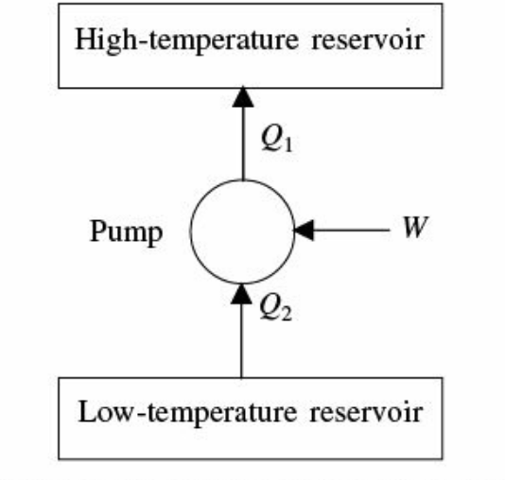
First law of thermodynamics
The fundamental implication of this law is that “although energy may be converted from one form to another, it cannot be created or destroyed”.
ENTHALPY
Enthalpy is denoted by H and is perhaps the most widely used of all thermodynamic functions. It is defined as
H = U + PV
Here U is the internal energy of the system, P the absolute pressure and V the volume of the system. Since U, P, and V are all state functions, any combination of them also must be a state function. Enthalpy is, therefore, a state function.

First law of Thermodynamics Flow process
Consider an idealised flow system as shown in below Fig. A fluid is flowing through the apparatus from section 1 to section 2. The velocity, specific volume, pressure, and height above the datum are represented by u, V, P, and Z respectively. The suffix 1 indicates conditions at section 1 and suffix 2 the conditions at section 2.
Heat Q is added per unit mass of the fluid by means of the heat exchanger and shaft work W is extracted by means of a turbine or any other suitable device.
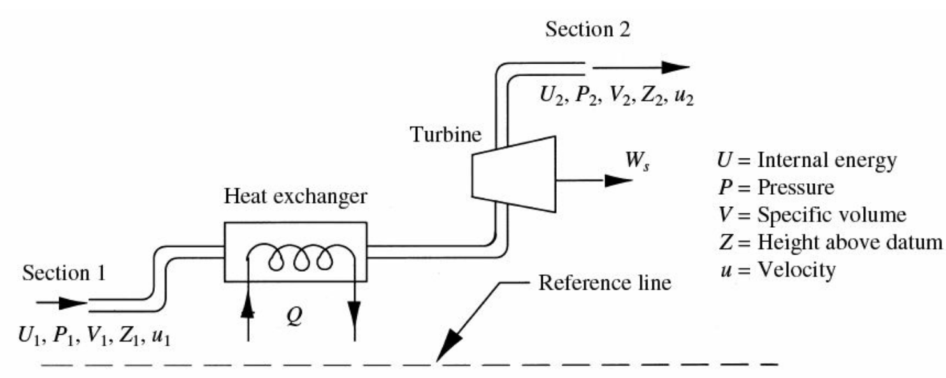

According to the first law of thermodynamics, the total energy with which the fluid is entering at section 1 plus the energy imparted to the fluid while it is in the system must be equal to the total energy with which the fluid is leaving the system at section 2.
Contributions to the total energy at section 1 are:
Internal energy: mU1
Potential energy: mgz1.
Kinetic energy: ½ mv1²
Fluid energy: P1v1
Contributions to the total energy at section 2 are:
Internal energy: mU2
Potential energy: mgz2.
Kinetic energy: ½ mv2²
Fluid energy: P2v2
Total energy at section 1 = mU1 + mgZ1 + (1/2) mv1²+ mP1V1
Total energy at section 2 = mU2 + mgZ2 + (1/2) mv2²+ mP2V2
Total energy imparted to the fluid is = mQ – mW
Combining the preceding three results, we see that for unit mass of fluid the energy balance give
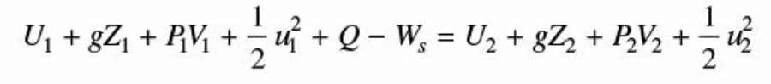
ΔH = Q – W
HEAT CAPACITY
The heat capacity of a substance is the quantity of heat to be supplied to effect a temperature rise of one degree. Thus
dQ = C dT
where C is known as heat capacity of the substance. Heat capacity of unit mass of a substance is also known as specific heat of the substance. The heat capacity depends on the way in which heat is supplied.
Constant volume process
U = Q – W
dU = dQ – dW
dU = dQ – PdV
For constant volume process dV = 0
dU = dQ
we know that dQ = C dT
dU = Cv dT

Constant pressure process
U = Q – W
dU = dQ – dW
dU = dQ – PdV
dU+Pdv = dQ
dQ = C dT
dH = Cp dT

Show that Cp – Cv = R
U = Q – W
CvdT = CpdT – dPV
From ideal gas law
PV = nRT
when n =1
PV = RT
dPV = R dT
CvdT = CpdT – RdT
Cp – Cv = R

